Marina Fleet

User Guide

|  |  |  |
| --- | --- | --- |
| Supervisor. | Yumna Khalid | |
| Batch. | 2209F1 | |
| Group. |  | |
| Serial No. | Enrollment Number | Student Name |
| 1. | Student1445693 | Syed Muhammad Sulaiman |
| 2. |  |  |
| 3. |  |  |
| 4. |  |  |

USER GUIDE

1. Layout Top

**Figure 1**

* Clicking on the logo will open the Home page.
* Clicking on the other navigational links will lead to their respective webpages.

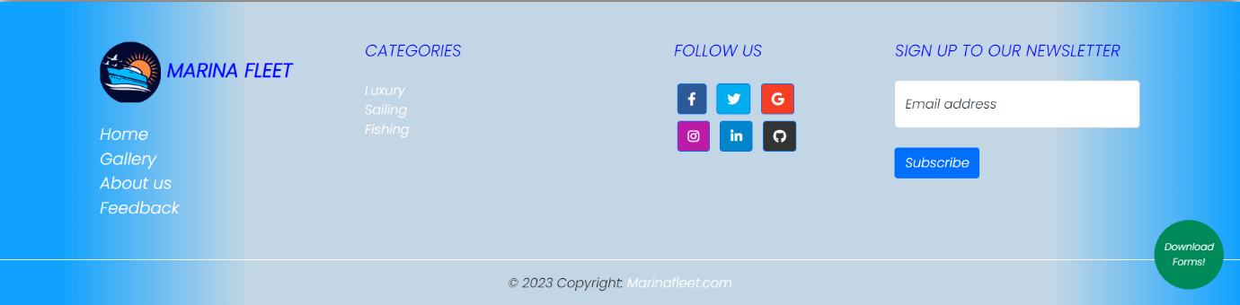2. Layout Bottom

**Figure 2**

* Clicking on the navigational links will open to their respective webpages.
* When the social icons are clicked, their websites will be opened on another tab.
* The input field can be used to write email addresses, on which newsletters will be received.
* When you will click the green button at the bottom which is saying ‘Download Forms’, it will open the ‘Download Forms page’.

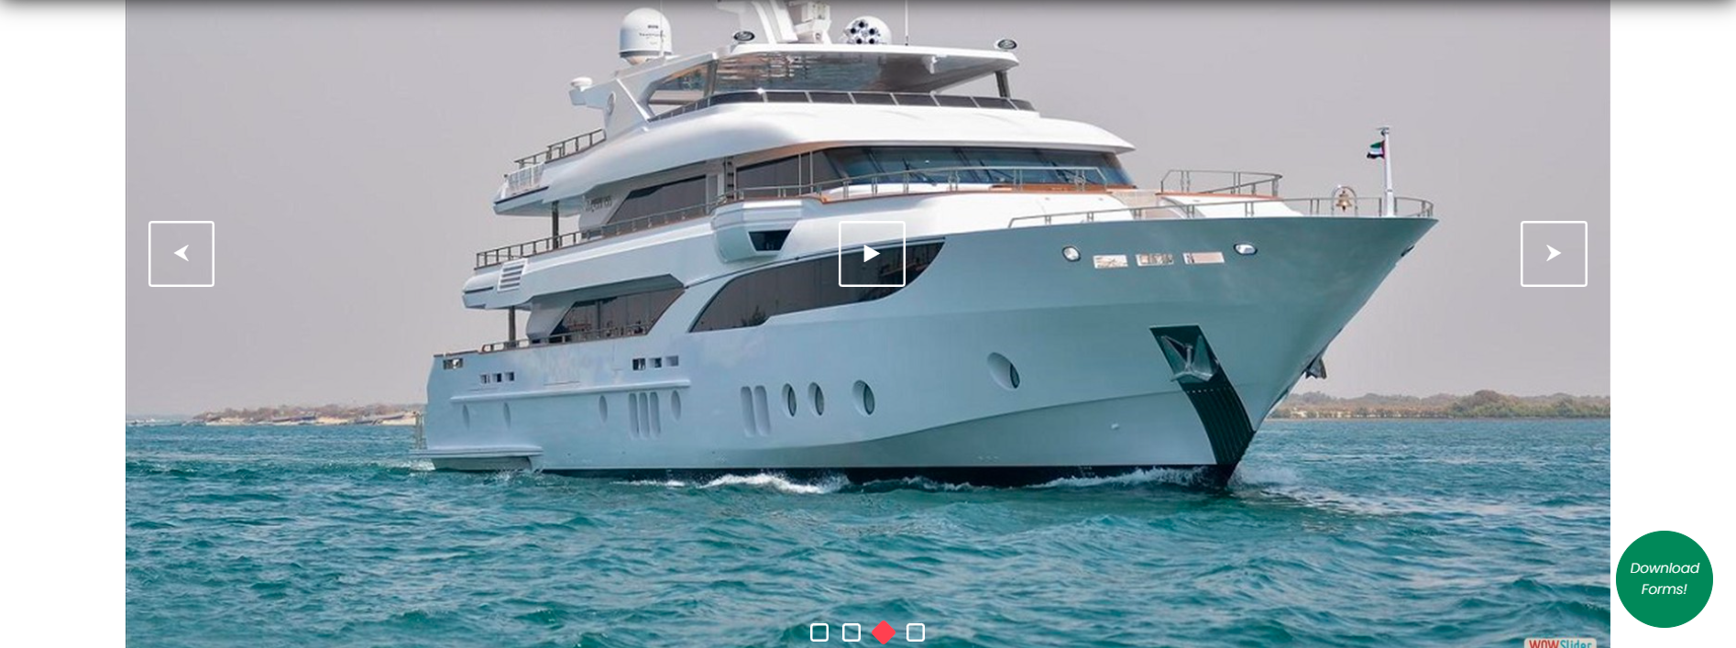3. Home Page

**Figure 3**

**Figure 4**

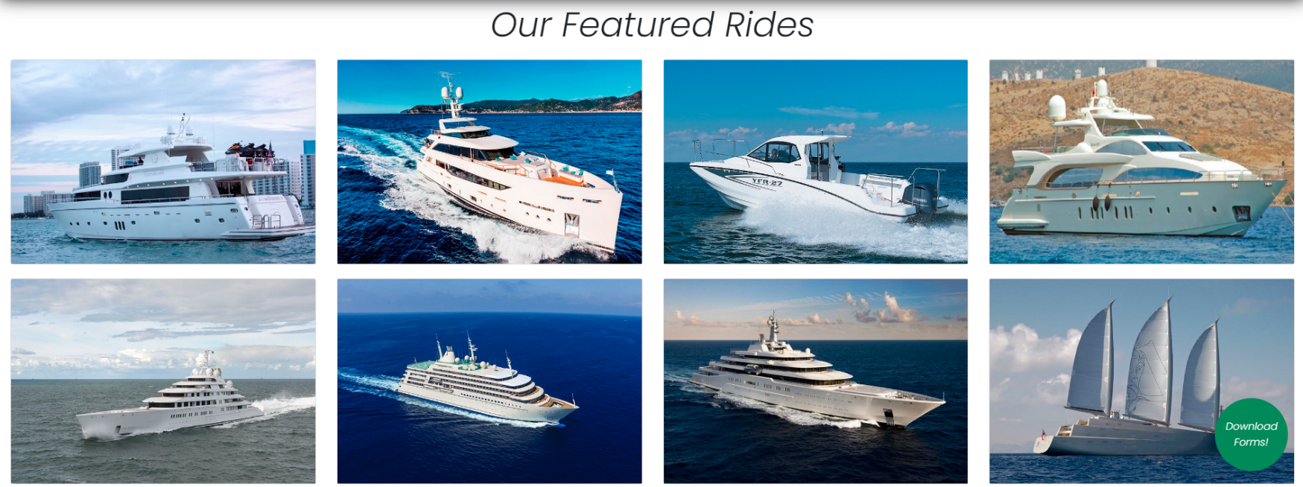

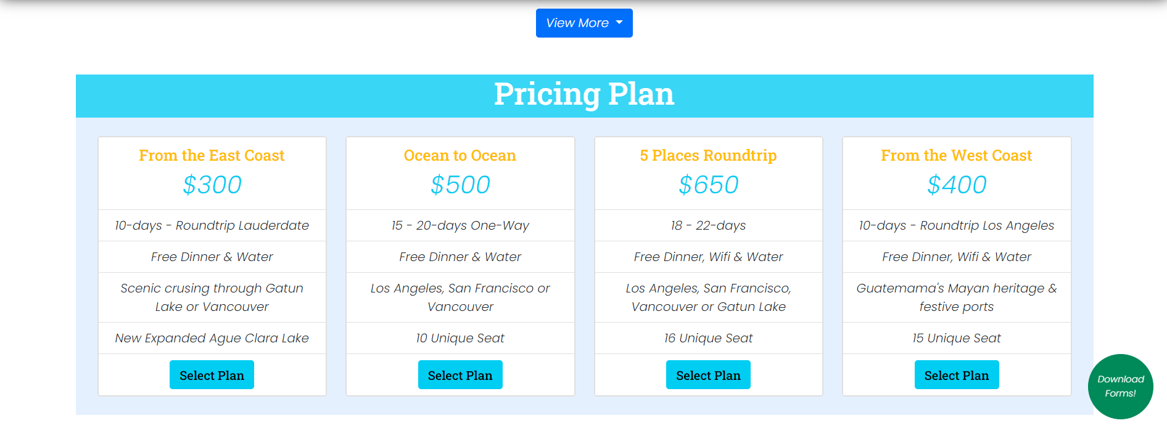 **Figure 5**

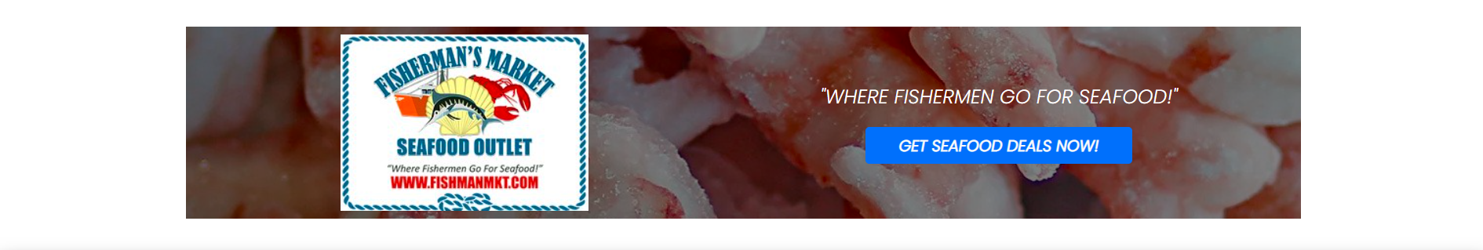

**Figure 6**

* In Figure 3, the next and previous images in the slider can also be seen by clicking the buttons on the left and right hand side.
* In Figure 5, the dropdown shows 3 links and each one opens a category.
* Figure 6 is an advertisement and when it is clicked, it opens another website.

4. Category pages:

* Luxury page
* Sailing Page
* 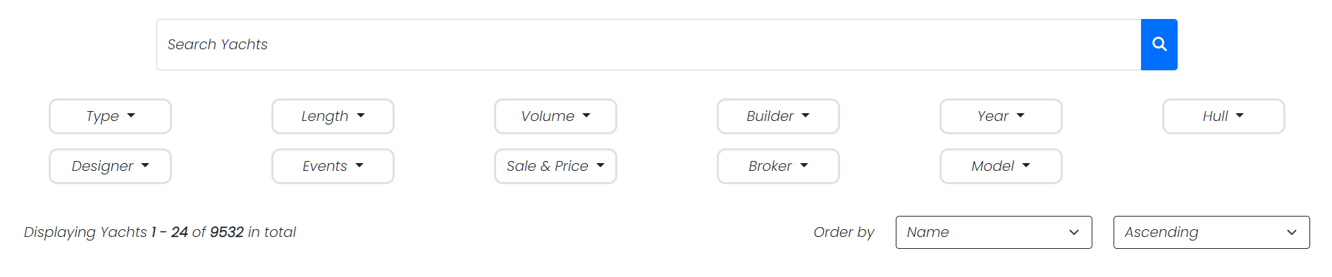Fishing Page

**Figure 7**

* 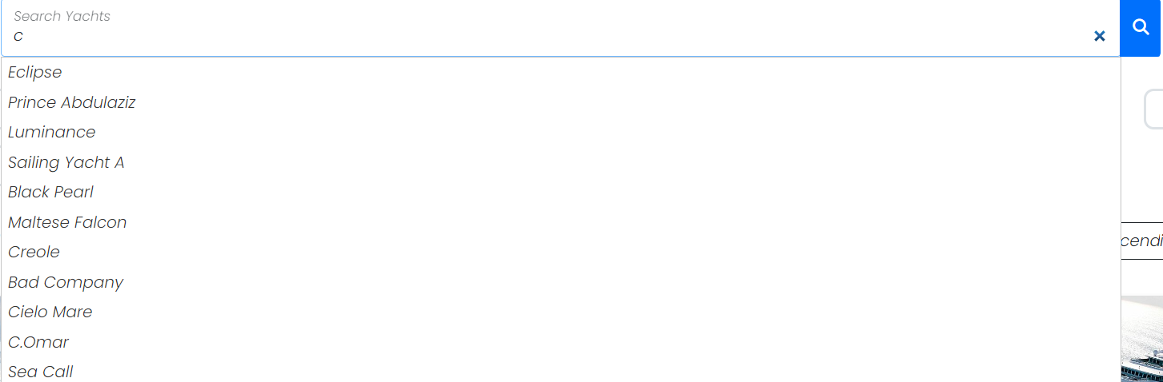When you will click on the search bar and start writing it will provide suggestions for the names of yachts as shown in Figure 8.

**Figure 8**

* In Figure 7, if you click on the dropdowns, it will show you different filters through which you can view yachts of different categories.
* You can also order the sequence of the yachts through the 2 dropdowns at the bottom of Figure 7.

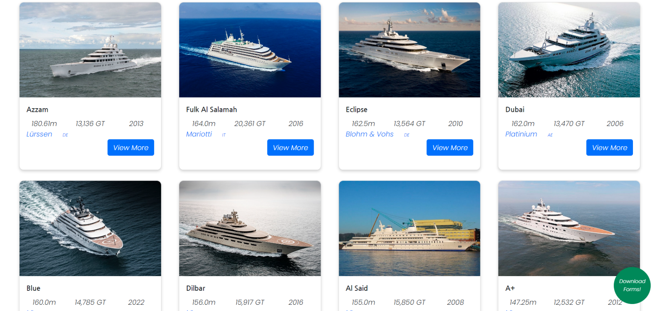 **Figure 9**

* 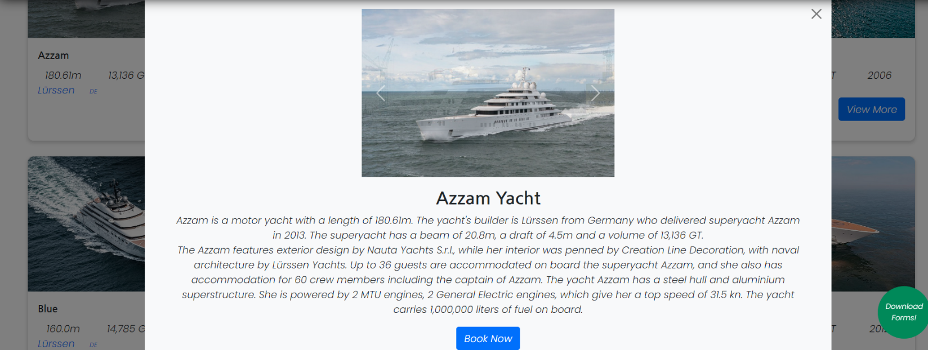To view additional information regarding a yacht, you can click on the blue button ‘View More’ which will show a popup like in the Figure 10

**Figure 10**

* If you want to close the popup, you can click on the small cross button at the top-right of the popup.

**Figure 11**

* You can click on the pagination to view the next or the previous pages.



5. Feedback Page

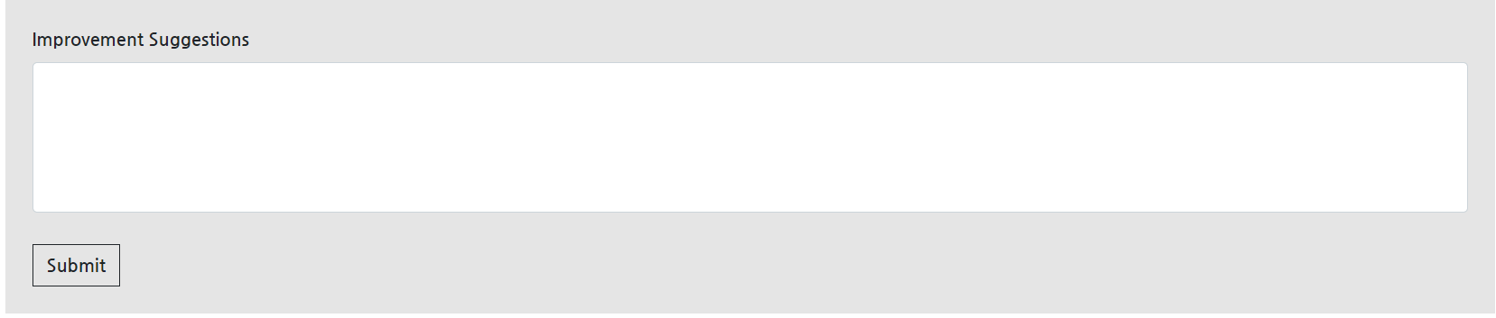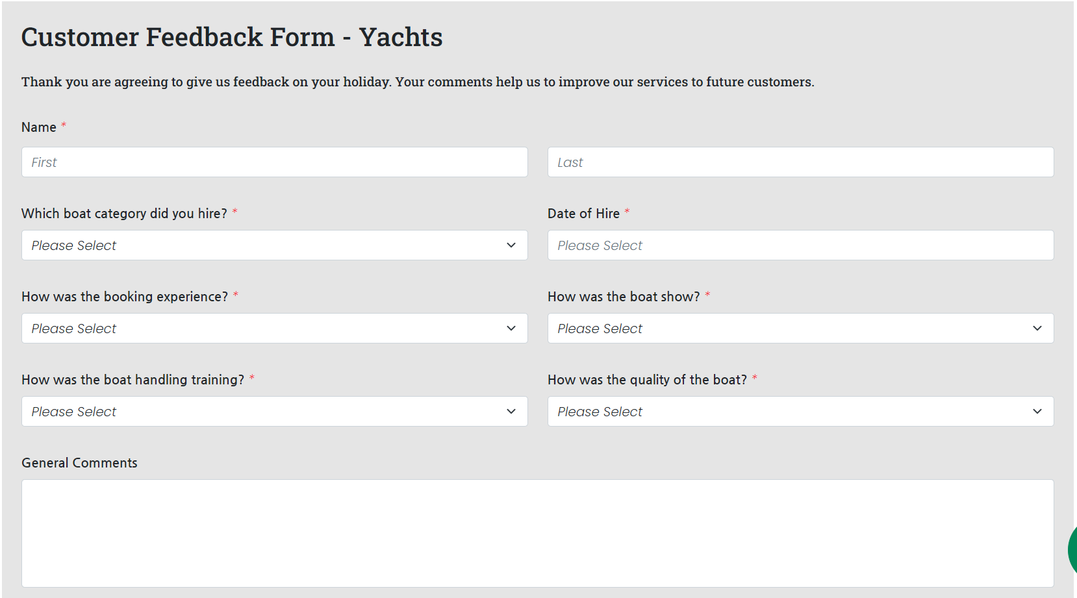

**Figure 12**

* First Name & Last Name
* Do not leave blank.
* Enter more than 3 characters.
* Dropdowns
* Do not leave blank.
* Please select an option from each dropdown.
* Date of Hire
* Do not leave blank.
* Choose the date from the date picker.
* General Comments & Improvement Suggestions
* Optional.
* No limits on character.
* 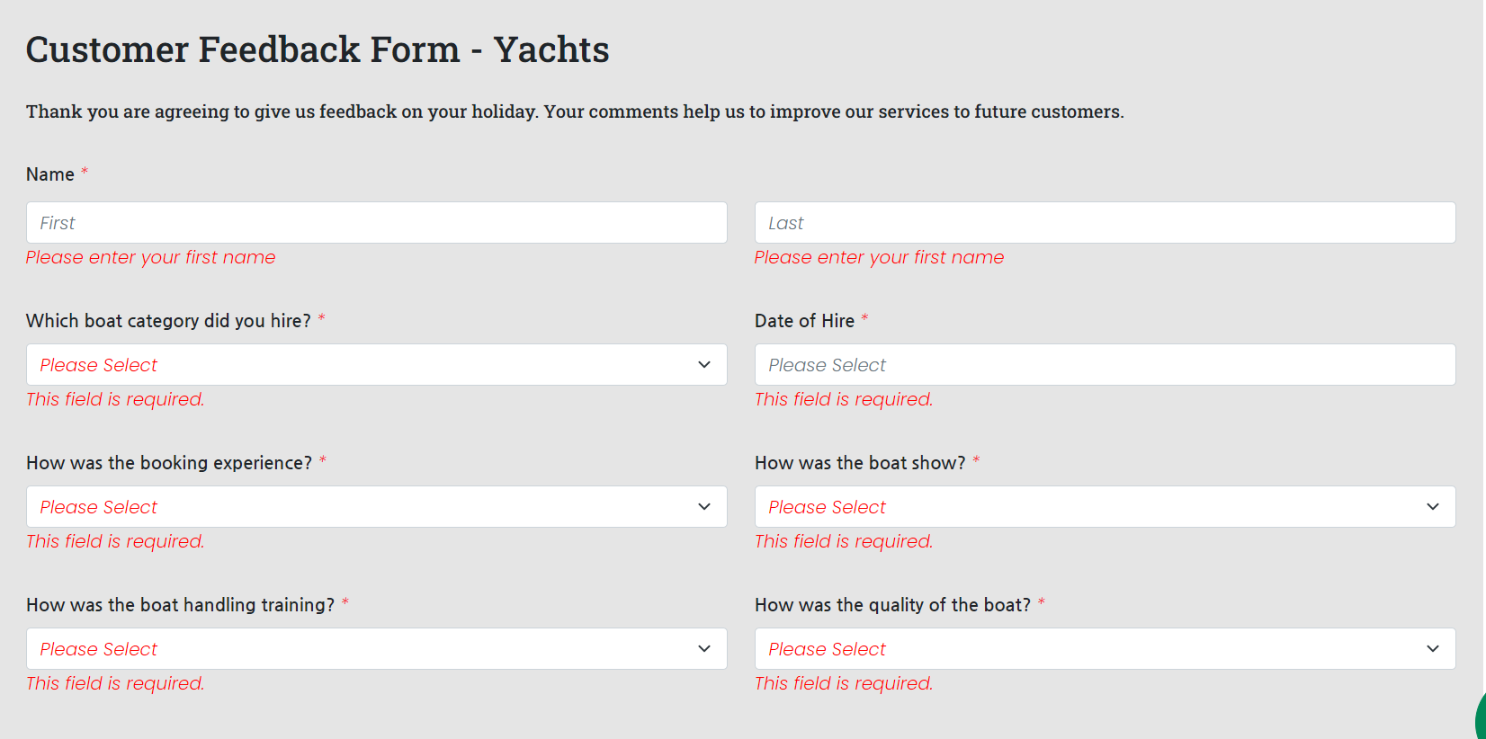If there will be an empty input field, then an error will be shown. Example is shown in Figure13.

**Figure 13**

* 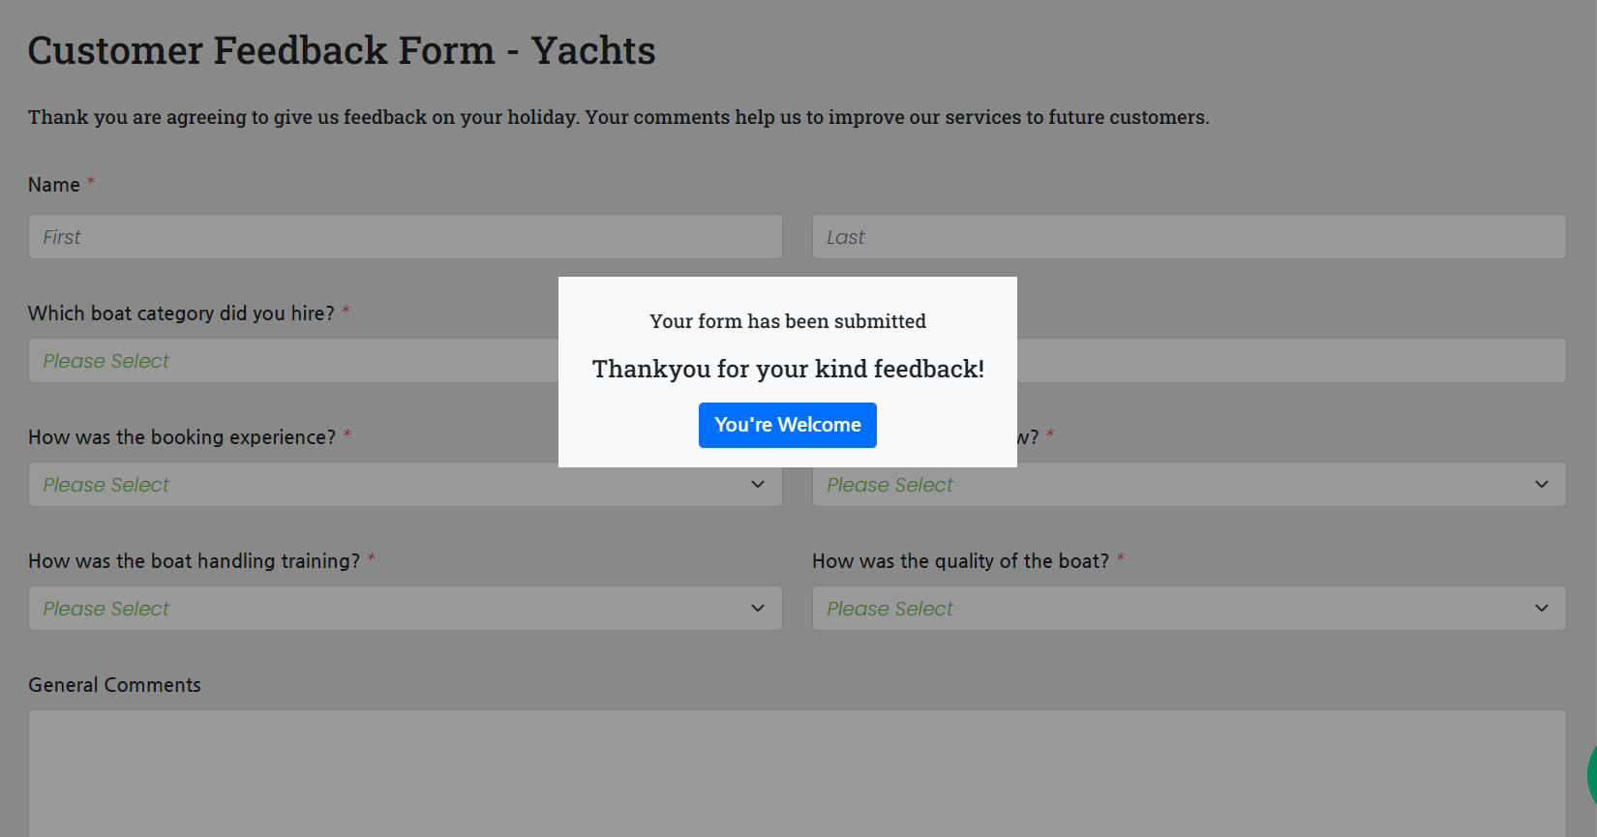When the form will be successfully submitted, then a dialog box will appear as shown in Figure 14.

**Figure 13**

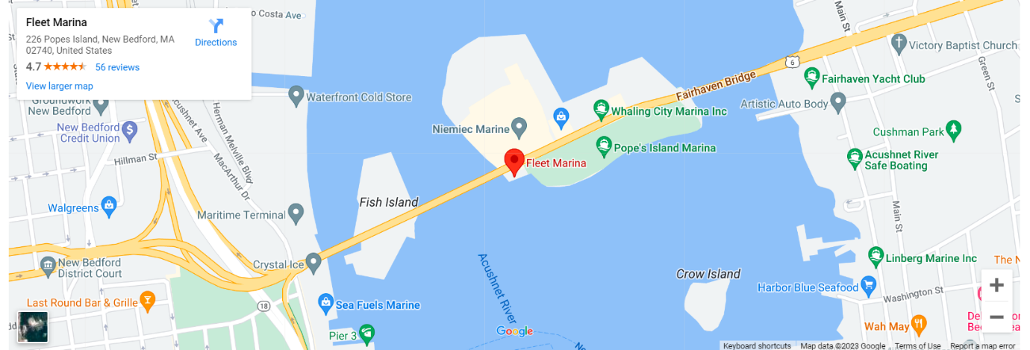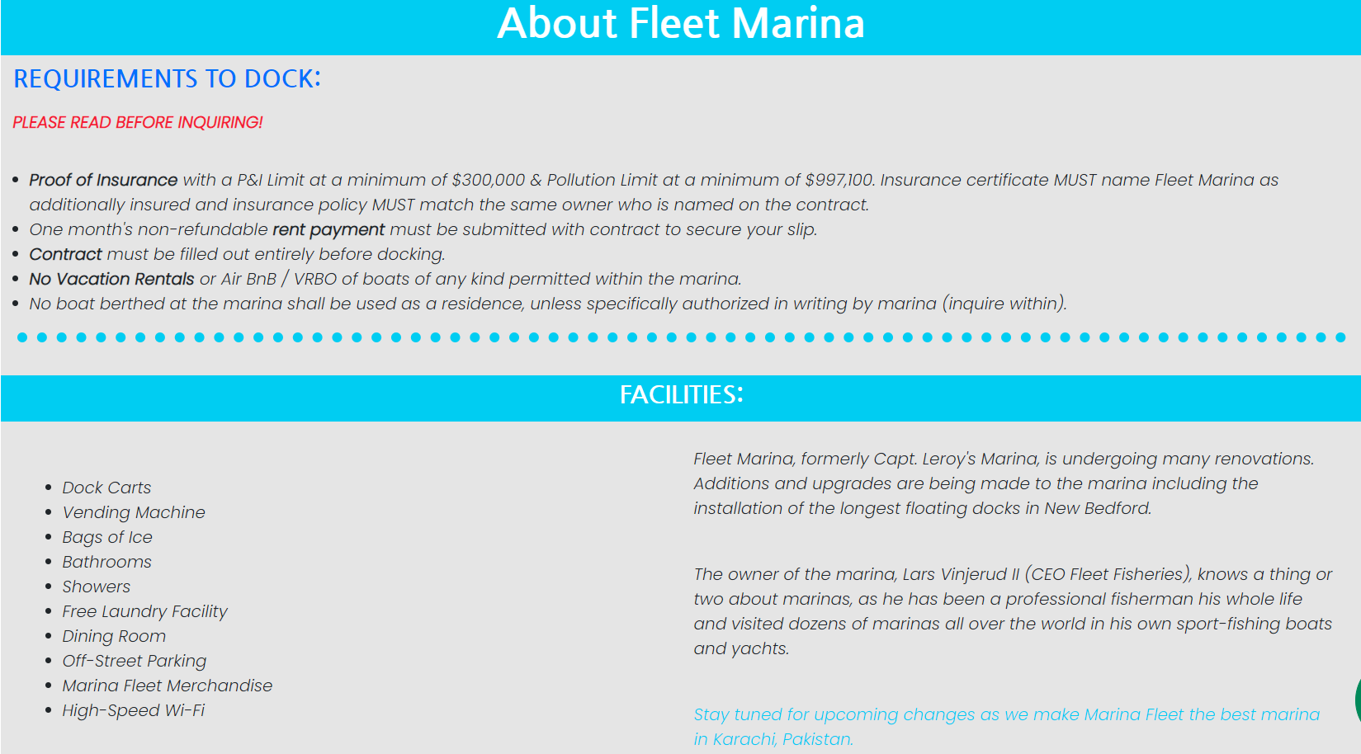6. About us Page

**Figure 14**

* The map in Figure 14 can be used to view the location.

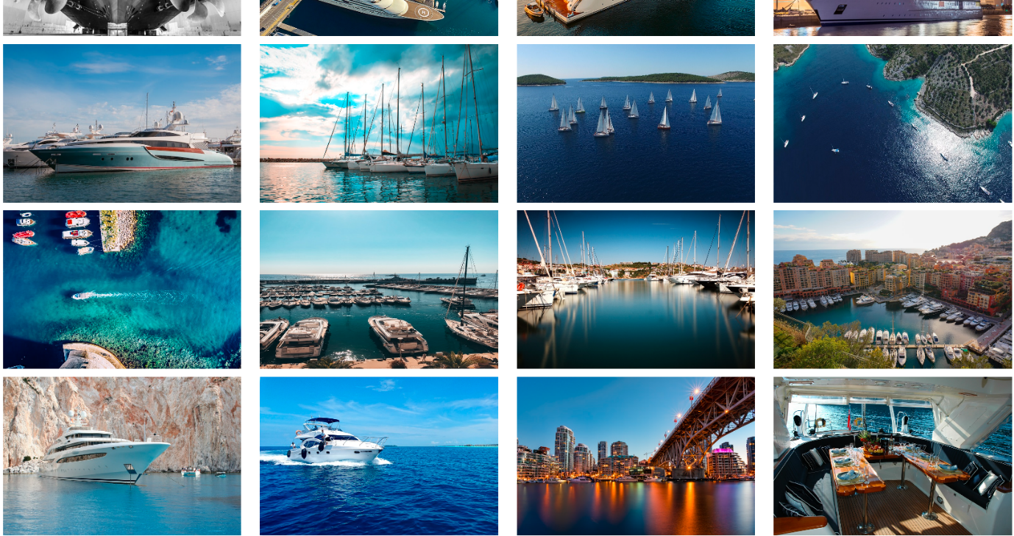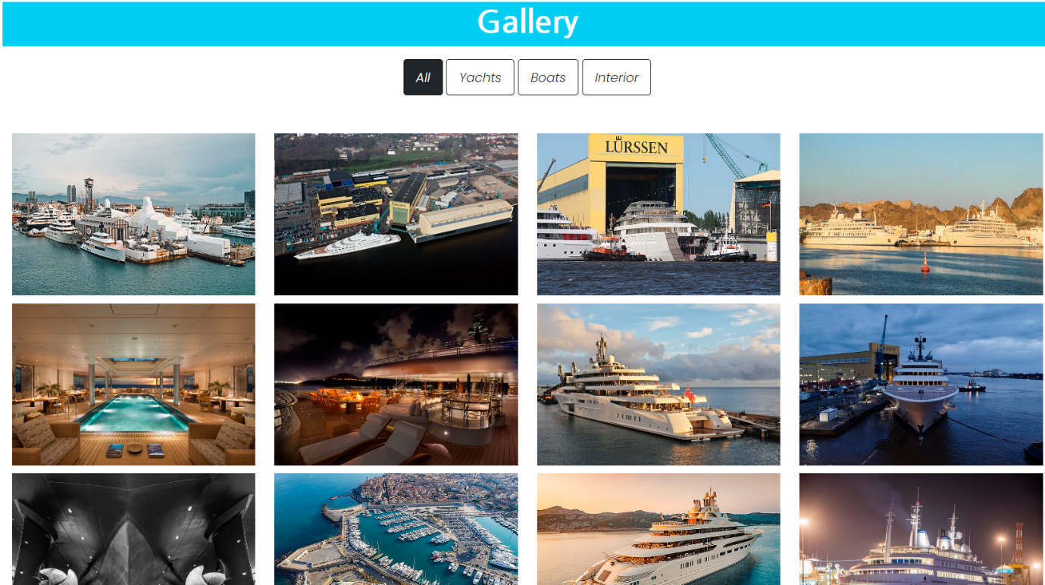7. Gallery Page

**Figure 15**

* When you will click on an image, a popup will open through which you can browse all the images as shown in Figure 16.

**Figure 16**

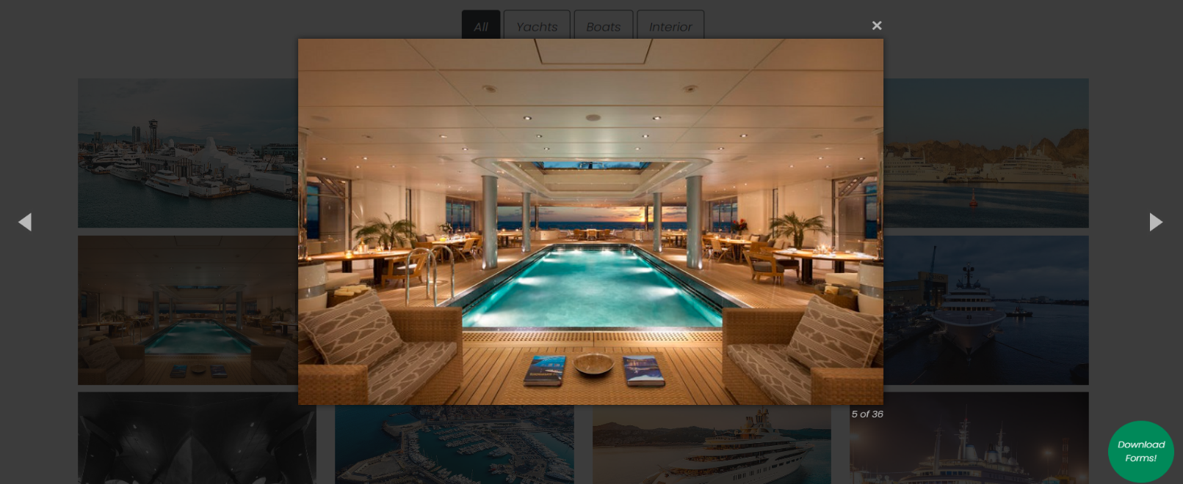Thankyou for reading the Documention [User-Guide]

Please Follow the instructions mentioned above!!